Data Handling and Visualization (DSA06)
Name: Prasanna M Reg. No: 1925260244
Set 14: Survey Results
Question 1. Create a stacked bar chart to display the distribution of answers for Question 1. Label the chart elements.
Program (R):
library(ggplot2)
survey <- data.frame(Respondent = factor(1:3),
Question1 = c("A","B","C"),
Question2 = c("B","A","A"),
Question3 = c("C","D","B"))
ggplot(survey, aes(x = Question1, fill = Respondent)) +
geom_bar() +
labs(title = "Distribution of Answers for Question 1",
x = "Answer Option", y = "Number of Respondents", fill = "Respondent") +
theme_minimal()
Output:
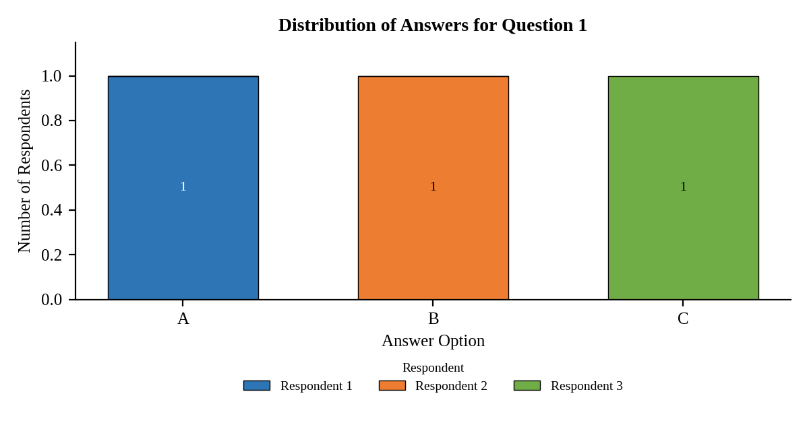
Interpretation:
Each answer option (A, B and C) was chosen by exactly one respondent for Question 1, so the responses are evenly spread and no single option is dominant.

Question 2. Generate a radar chart to visualize the overall pattern of responses across all three questions.
Program (R):
library(fmsb)
code <- function(x) match(x, c("A","B","C","D")) # A=1, B=2, C=3, D=4
radar_df <- data.frame(Question1 = code(survey$Question1),
Question2 = code(survey$Question2),
Question3 = code(survey$Question3))
rownames(radar_df) <- paste("Respondent", 1:3)
radar_df <- rbind(rep(4, 3), rep(1, 3), radar_df) # max and min rows
cols <- c("blue", "red", "darkgreen")
radarchart(radar_df, axistype = 1, pcol = cols, plwd = 2, plty = 1,
cglcol = "grey", title = "Response Pattern Across Questions")
legend("topright", legend = rownames(radar_df)[-(1:2)], col = cols, lty = 1, bty = "n")
Output:
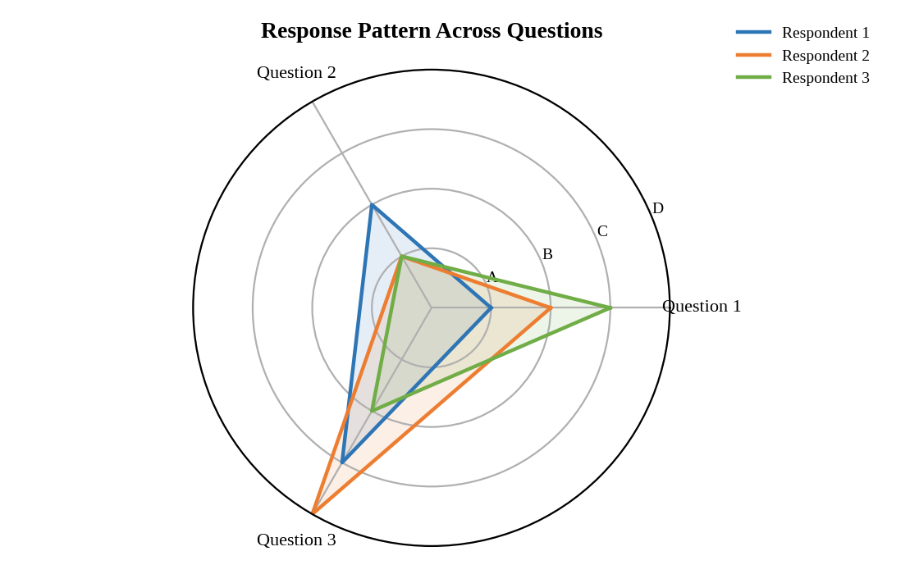
Interpretation:
Answers are coded A = 1 to D = 4. Respondent 1 rises steadily from Question 1 to Question 3. Respondent 2 shows the sharpest spike at Question 3 (answer D). Respondents 2 and 3 both chose A for Question 2, so the shapes meet at the lowest point on that axis.

Question 3. Build a table to show the survey response data for each respondent. Label the table elements.
Program (R):
library(knitr)
kable(survey, align = "c",
col.names = c("Respondent", "Question 1", "Question 2", "Question 3"),
caption = "Table 14.1: Survey Response Data")
Output:
Table 14.1: Survey Response Data
Respondent | Question 1 | Question 2 | Question 3
1 | A | B | C
2 | B | A | D
3 | C | A | B

Interpretation:
The table lists the answer given by each of the three respondents to Questions 1, 2 and 3. Answers A and B each appear three times, C twice and D once (Respondent 2 on Question 3).

Question 4. Develop a Tableau dashboard combining the stacked bar chart, radar chart, and the table for interactive exploration of survey responses.
Procedure (Tableau):
1. Open Tableau, click Connect, choose Text file / Microsoft Excel, select "Survey_Results.csv" and open Sheet 1.
2. Select the Question 1, Question 2 and Question 3 columns, right-click and choose Pivot. Rename the new fields to "Question" and "Answer".
3. Sheet 1 (Stacked bar): Columns = Question; Rows = COUNT(Respondent); drag Answer to Color and Label; mark type = Bar.
4. Sheet 2 (Radar): create calculated fields Score (A = 1, B = 2, C = 3, D = 4), Angle = (Question Index - 1) * 2 * PI() / 3, X = [Score] * COS([Angle]) and Y = [Score] * SIN([Angle]). Columns = X, Rows = Y, Path = Question Index, Color = Respondent, mark type = Line (repeat Question 1 to close the shape).
5. Sheet 3 (Table): Rows = Respondent; Columns = Question; drag Answer to Text.
6. Click New Dashboard, name it "Survey Dashboard", set Size to Automatic and drag the sheets onto the canvas (charts on top, table below).
7. Select each chart and click the "Use as Filter" icon so that clicking a bar or slice filters the other sheets; keep tooltips enabled.
8. Add a title to every sheet, adjust labels and colours, and save the workbook (File > Save As, .twbx).

Output:
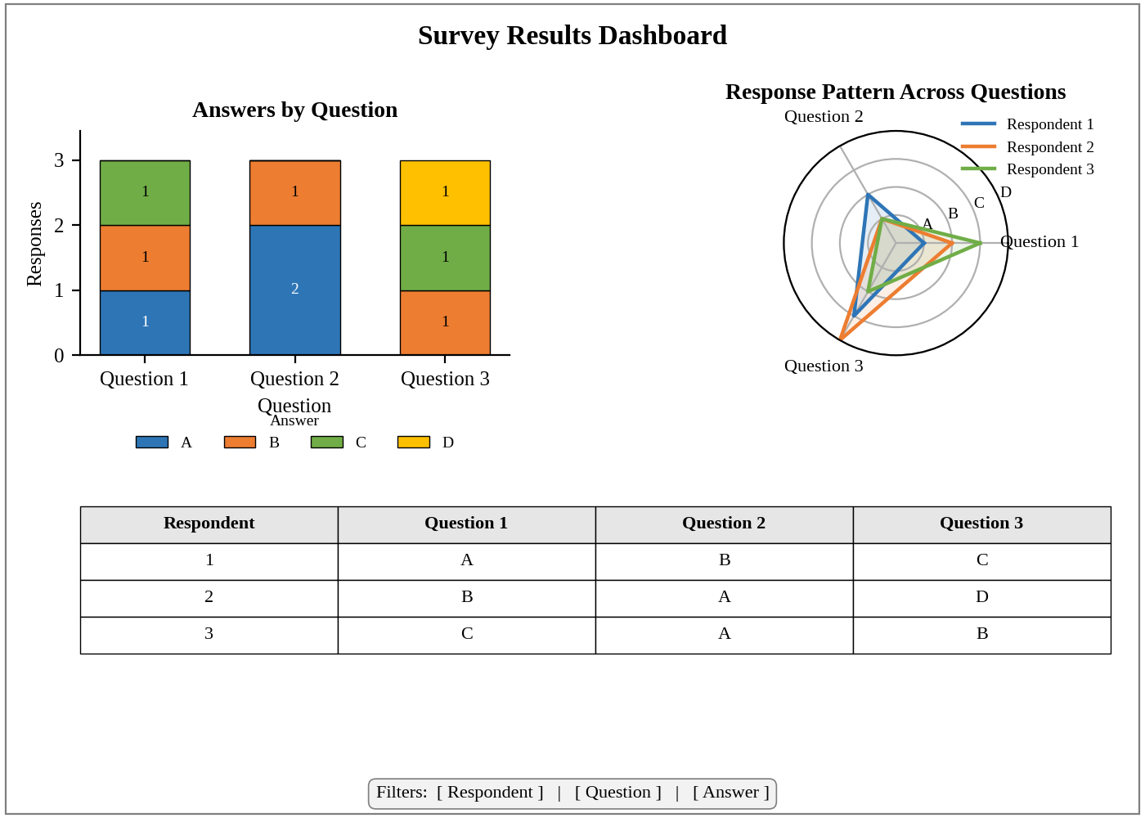
Dashboard layout (preview of the Tableau output).
Interpretation:
The dashboard lets a user click a respondent or an answer and see the stacked bar, radar shape and table update together. It shows that B is the only answer used on all three questions, that A dominates Question 2, and that D is a one-off choice on Question 3.

